Lesson 05 Demo 01

Creating Subnet and Vnet

Objective: To create a subnet inside a virtual network in the portal
Tools Required: None

Prerequisites: None

Steps to be followed:
- Create a virtual network in the portal

Step 1: Create a virtual network in the portal

- Sign in to the Azure portal, search for Virtual networks, and click on Create virtual network

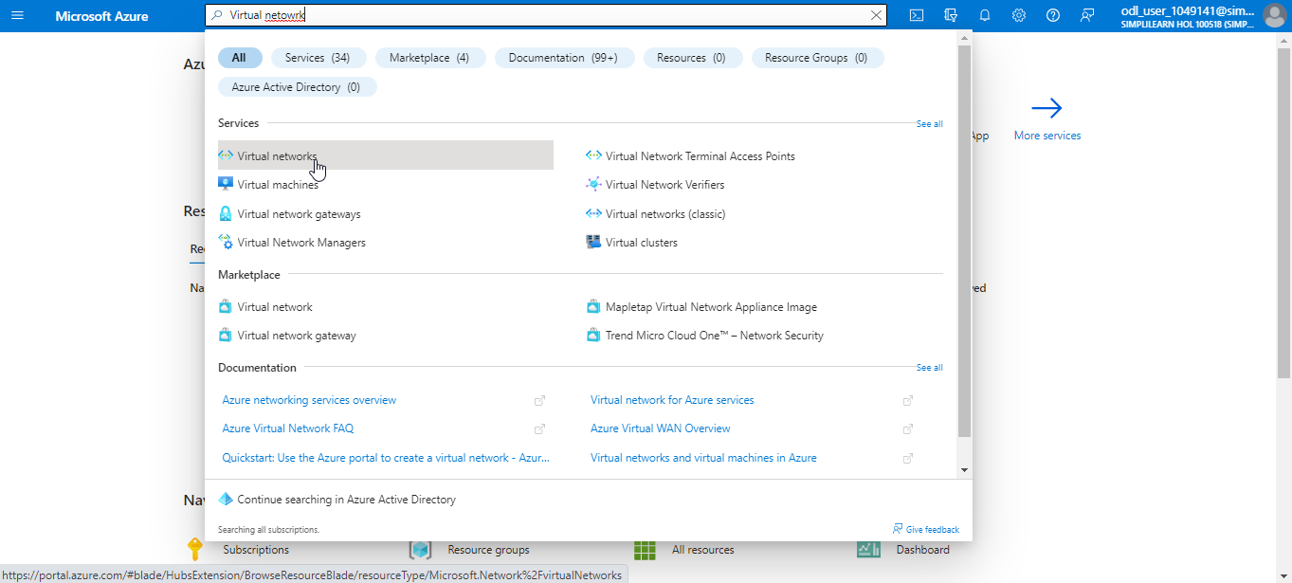

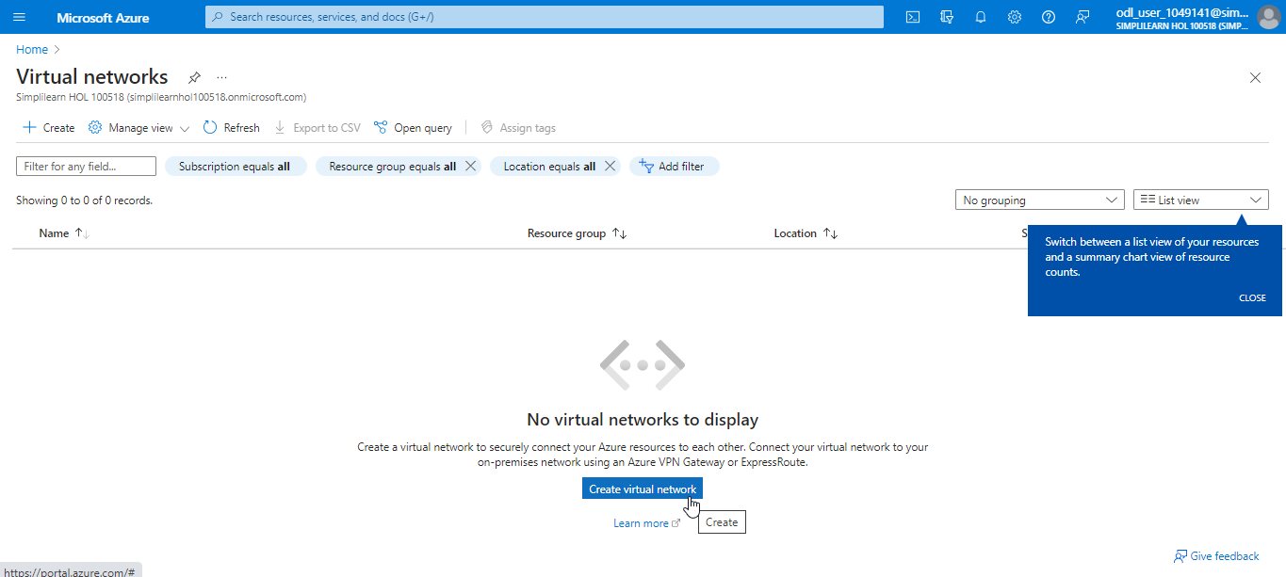

- In the Basics tab, provide the below details:
Subscription: Select the subscription, Resource Group: Select new or choose an existing resource group, Name as myVet1 and Location: Select the location and then click on Next> Next> Add> Review + create> Create

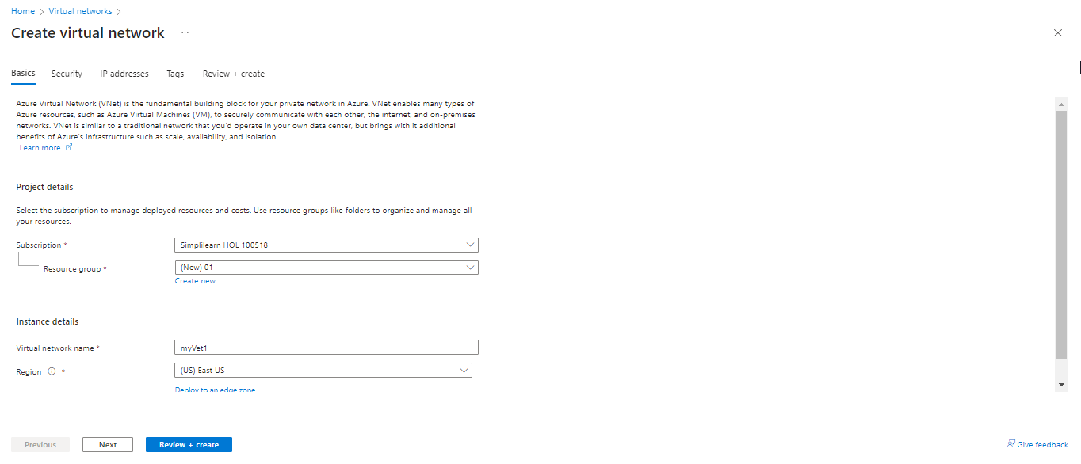

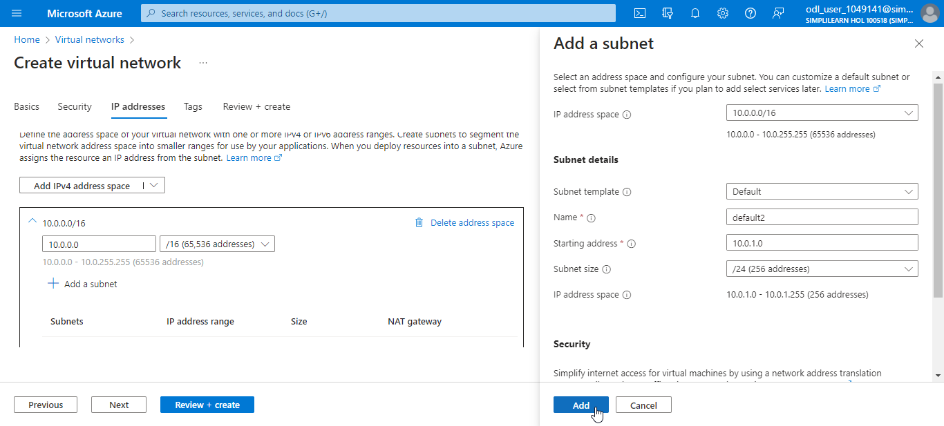

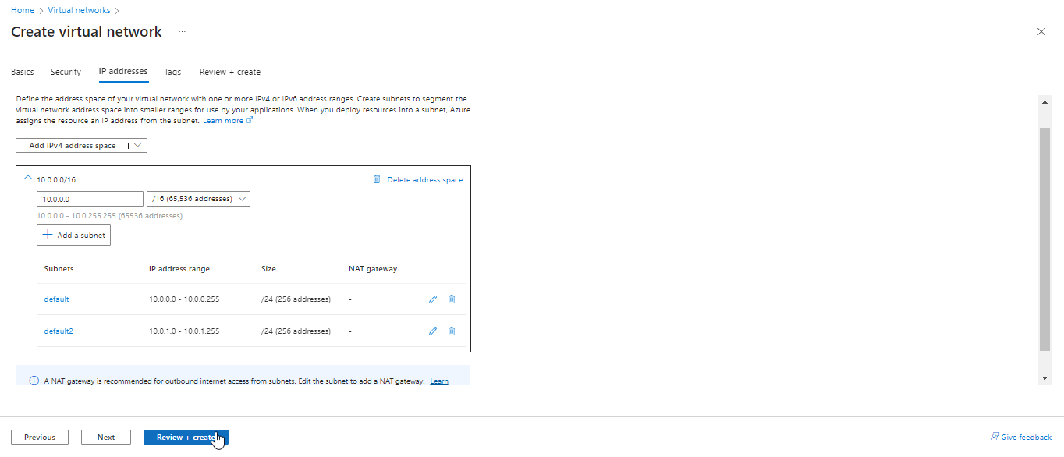

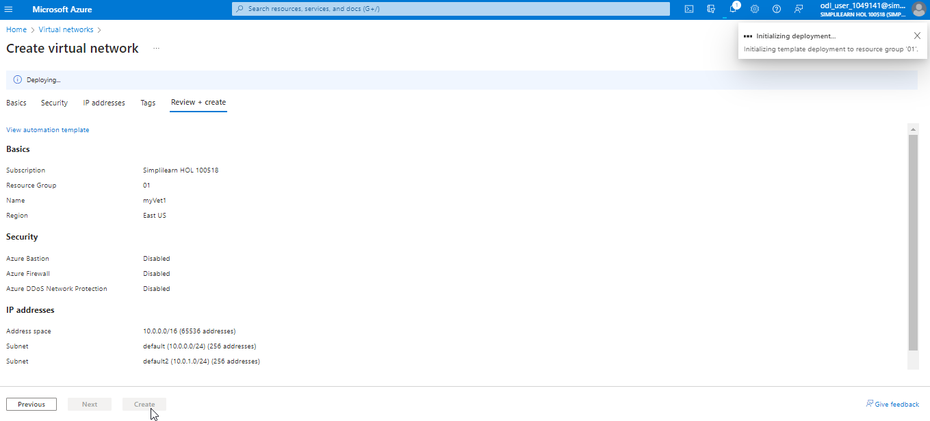

Output will look as follows:

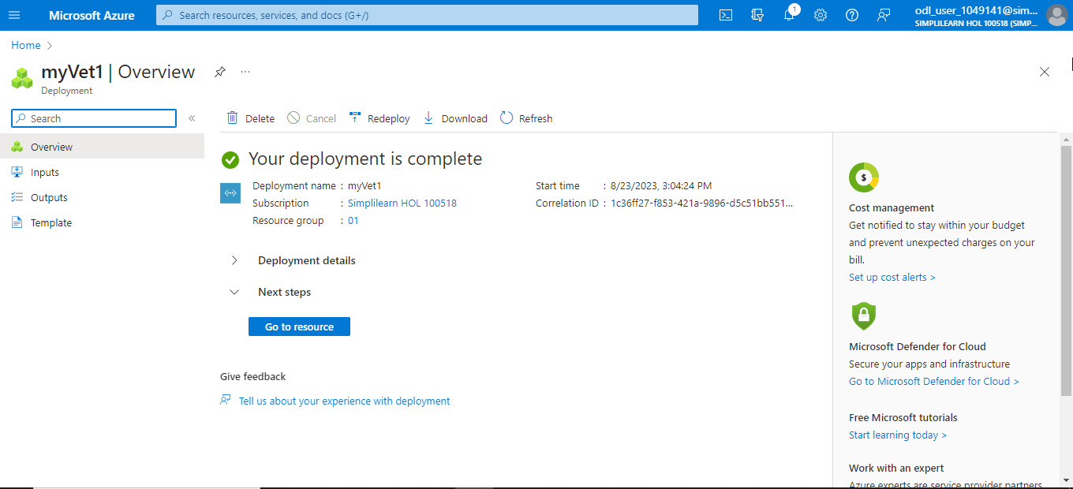

You have now successfully created the virtual network and subnet inside this virtual network.

